Hartree-Fock Self Consistent Field Programming Exercises

Project A*

Write an SCF program to calculate the SCF energy of the H₂O molecule with the STO-3G and DZ basis sets.

Integrals should be read from the ASCII supplied file and held in core – utilise particle symmetry and hold all integrals (including zero valued integrals in a multi-dimensional array).

Project B**

When project A is completed, transform the Fock matrix in the AO (SO) basis into the MO basis and examine the diagonality of the latter.

Project C*

Modify your SCF program to calculate the SCF energy of any molecular system (closed shell) utilising dynamic memory allocation to hold all integrals in core for an unspecified basis set.

Project D*

Modify your SCF program to calculate the SCF energy of any molecular system (closed shell) with any size of basis set. The 2-e integrals should be read sequentially from the file and directly processed into the Fock matrix.

Project E**

Interface your SCF program from Project D to Gaussian as link 502, reading information from the int, chk and rwf files using Gaussian library routines.

* The AO (SO) integrals will be provided in blocked form. You may use the diagonalisation routine DIAGD within the Gaussian library (see the Gaussian Programmers Manual) or a suitable NAG routine, F02FAF (see www.nag.co.uk).

** Optional projects.
Suggested procedure for an SCF program

A Preliminary Processing

1) Read in nuclear repulsion energy (E_{nuc}).

2) Read in overlap integrals (S).

3) Read in kinetic energy integrals (T).

4) Read in potential energy integrals (V).

5) Form one electron integral matrix (H).

H_{μν} = T_{μν} + V_{μν} (A1)

6) Read in two-electron repulsion integrals (μν|ρσ).

Note:
(12|34) = (12|43) = (21|34) = (21|43) = (34|12) = (34|21) = (43|12) = (43|21)

Also: where
μ ≥ ν, ρ ≥ σ, μν ≥ ρσ

μν = μ*(μ–1)/2 + ν (A2a)
ρσ = ρ*(ρ–1)/2 + σ (A2b)
μνρσ = μν*(μν–1)/2 + ρσ (A2c)
B Construction of the S^{–½} Matrix

1) Diagonalize the S Matrix.
SL_{s} = L_{s}Λ_{s} (B1)
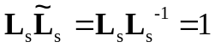 (B2)

2) Form the S^{–½} Matrix.
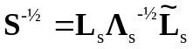 (B3)

C Construction of an Initial Density Matrix

1) Form an initial (transformed) 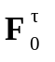matrix using the H matrix.
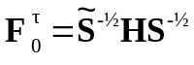 (C1)

2) Diagonalize the 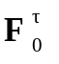matrix using a standard eigenvalue subroutine.
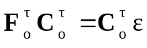 (C2)
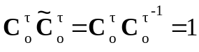 (C3)

3) Form the SCF eigenvector matrix.
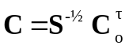 (C4)

4) Form the first density matrix (D).
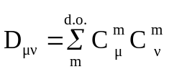 (C5)

Where 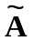is the transpose of matrix A.
D The SCF Iteration

1) Form the new Fock matrix (F) including two-electron integrals.
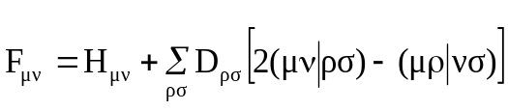 (D1)

2) Calculate the electronic and total energies.
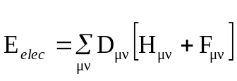 (D2)
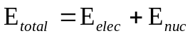

3) Transform the Fock matrix.
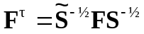 (D3)

4) Diagonalize the Fock matrix.
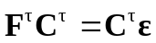 (D4)

5) Construct the new SCF eigenvector matrix.
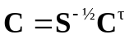 (D5)

6) Form the new density matrix.
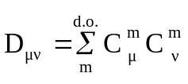 (D6)

7) Test convergency of density matrix and energy.
(i) RMS of density matrix elements:
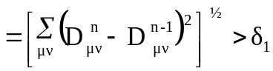 (D7a)
(ii) Energy difference:
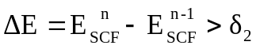 (D7b)

8) If SCF is not attained go back to step D1.

